**GasBuddy Project Closure Document  
Michael Johnson  
Southern New Hampshire University**

**Table of Contents**

Introduction 4

Verification Plan 5

Feedback 5

Feedback Criteria 5

Test Cases 6

Postmortem Summary 7

Methodologies 7

Method Evaluation 8

Risk Mitigation 9

Project Status 9

Objectives 9

Issues 10

Alternatives/Recommendations 10

Communication 11

Future Enhancements 12

Implementation Support 12

Maintenance Plan 13

Appendix 14

Figure 1. Work Breakdown Structure (Gantt Chart) 14

Figure 2. GasBuddy Use Case Diagram 15

Figure 3. Final Implemented Design (Search Page) 16

Figure 4. Final Implemented Design (Coupon Page) 17

Design Explanations 18

# **Introduction**

While GasBuddy is a long running company with a large userbase, the company has started seeing a notable slowdown in the amount of new and returning users. After some initial research, the GasBuddy mobile application was found to look outdated and was lacking many of the functions and incentives that the competitors were offering their users. This was a large factor leading to the decline that GasBuddy was witnessing in the userbase.

The GasBuddy redesign project brought with it the potential to not only boost the companies userbase but also provides the company with a new revenue stream through numerous partnerships with the various c-stores offering the mobile coupons. For these reasons, the redesign project was vital to the continued growth of the company by providing users with a more modern look and feel.

By redesigning the mobile application, GasBuddy received a fresh and more modern look while providing users with new mobile coupon functionality so that they can save on other items at the locations they are fueling at. This is the new mobile coupon system built into the application. With this system, users can utilize the GPS in their mobile devices to pinpoint the business they are getting fuel from and, if they are a GasBuddy partner, will be provided with coupons for savings on other items in the store, helping GasBuddy better align with what competitors in the market are offering.

# **Verification Plan**

## **Feedback**

Feedback was collected in a few different ways according to the verification plan. Since GasBuddy utilized the Agile methodology for the project, testing was conducted frequently throughout the project at the end of each sprint. This is where the deliverables from the sprint could be tested to ensure they met the requirements set and help provide feedback to the team and stakeholders before moving forward.

By using the Agile method, the team can provide updated artifacts to the stakeholders on a regular basis consisting of the current mobile application version. Stakeholders can then test the system themselves to ensure it is up to standard and delivers on the objectives specified. This, along with the user testing conducted by the team, will provide ample feedback of the system.

Any feedback gathered during the testing cycles was then catalogued in an issue tracker within the project plan to rank and follow up on. This allowed the team to then track the issues as they were fixed, if found actionable, and move on with the development process. This worked well as team members were assigned to feedback based on whether is was actionable and the department in which the task fell.

## **Feedback Criteria**

During each of the testing phases, and continually throughout the project, feedback was gathered. This feedback was assessed to ensure that it was actionable and relevant to the project. The team did this by assigning a value to the feedback item to help indicate the level of importance in relation to the project. These rankings consisted of a number scale from 1-4 with 1 being vital to the project and 4 being insignificant to the project.

Based on the ranking system, items ranked vital to the project consisted of major flaws in the design of functions of the mobile application or issues with the security. These were items that had to be fixed for the project to be successful. Items ranked insignificant were superficial items that did not add any value to the project or items that increased project scope and were not necessary. The ranking pertains to the relevance the item had to the project and actionable feedback was then ranked with a 1. Items ranked between 2 and 3 might have been actionable if they did not drastically change the project scope or budget and could be done within the project’s original timeline. Items that were ranked with a 4 were neither relevant nor actionable.

## **Test Cases**

Numerous test cases were utilized during testing to help ensure all objectives were met and the mobile application functioned as intended. These test cases were tested by various individuals consisting of existing GasBuddy users and users new to the platform and were centered around confirming the objectives identified for the project had been met. Each test case included a task for the user to complete and would either pass or fail depending on if the user could complete the tasks defined. These test cases also included a place to note any issues captured during testing, such as a user stating something was hard to locate or a user’s body language at a specific part of a task. The test cases also included items that consisted of both the mobile applications functionality and the design.

# **Postmortem Summary**

## **Methodologies**

Since the project was done utilizing the existing GasBuddy platform and its framework, use of the Agile methodology was used. This provided the team with multiple sprints in which development of their deliverables were completed and tested. The use of the Agile methodology also allowed for various cycles of testing throughout the project, which helped to catch issues early in the project lifecycle.

The project consisted of five phases, following well known strategies that led to other successful projects. These phases included the research phase, initial design phase, redesign/rebrand phase, development phase, and the final testing phase. Near the end of each phase, the team tested (when applicable) the deliverables completed during the phase. This helped ensure no critical issues were realized near the end of development.

The research phase was used to help identify risks and mitigations for the risks through risk analyses. This time was also used to work on recruiting c-stores to partner with the company and take part in the new mobile coupons offered through GasBuddy. This phase was also used to identify strengths and weaknesses of the GasBuddy mobile application compared to other competitors in the market.

In the initial design phase, design mockups and wireframes were created to utilize for stakeholder feedback as well as an initial round of user testing. The phase concluded with a meeting to approve the final design plan for the new mobile application design. In the following phase, the redesign/rebrand phase, the new design plan was implemented, and a prototype created for user testing and finale design approval from stakeholders.

Following the design phases, work began on development of the new mobile coupon functionality for the mobile application. A quick dev meeting to ensure the team was on the same page marked the beginning of the phase followed by the integration of GPS services, the addition of the c-stores that partnered with GasBuddy into the database, and development of the mobile coupon function. The final testing phase was where everything was wrapped up. Final testing of the GasBuddy application was conducted to check for any issues before the system was pushed live. This included a meeting with stakeholders to go over the finished product.

## **Method Evaluation**

Keeping to the schedule provided in the Gantt chart and utilizing the five phases ensured the project was on schedule and did not deter from the original scope and requirements provided in the initial project proposal. Using the Agile methodology provided a fluid project environment and allotted time at the end of each sprint for testing, which ultimately saved time by finding issues early in the project, leaving the team with a finished product that functioned well with minimal issues to combat towards the end of the project lifecycle. These factors led to the success of the project.

Other vital tools utilized for the success of the project were Microsoft Project, which was used to create the project Gantt chart which detailed all the tasks, milestones, and deadlines associated with the project. This helped to keep each of the teams on track during development. Microsoft Visio was used to detail the use cases for the new GasBuddy mobile application. This helped provide in-depth information to the development team on the use needs of the application.

## **Risk Mitigation**

Throughout the project implementation, numerous risks were identified that could threaten the success of the project. Issues integrating the mobile application with c-store locations could prevent the mobile coupons from working correctly or at all. This could lead to further issues and loss of reputation. To mitigate this risk, multiple rounds of testing were conducted on the mobile coupon feature to ensure the GasBuddy mobile application correctly interfaced with the c-stores in the database.

Scope creep brought on by stakeholders wanting additional functions or features added or through team members working outside of the task schedule was another risk that needed to be mitigated as there was always one more thing that could be added. This risk was easily mitigated by following the feedback criteria set for the project and staying consistent with the tasks listed in the work breakdown schedule.

# **Project Status**

## **Objectives**

The main objective for the GasBuddy redesign/rebrand project was to refresh the look and feel of the mobile application to draw in new users, growing the userbase without losing any existing users, and provide a unique experience that set them apart from other competitors in the market. This included a new application layout and scheme based on both stakeholder and user feedback.

The second objective for the project was to create a mobile coupon function that provided users with coupons to stations they were fueling to help them save even more. This objective also provides GasBuddy with a new revenue stream through the partnerships with various c-stores that signed on to provide coupons for the feature.

While not yet fully implemented, the GasBuddy redesign project is set to fulfill these objectives. The implementation plan provides ample data to help the team succeed in delivering on each objective and creating an application that provides users with the savings and unique experience expected.

## **Issues**

There were not many issues that the team ran into during the project. The largest risks were that enough c-stores would not want to partner with GasBuddy, making the mobile coupon feature all but useless. This risk never came to light as the team in charge of reaching out during the research phase ensured there would be enough c-store interest to make the feature worth the development.

The other issue that needed to be mitigated was found in testing the GPS functionality in the mobile application. In some instances, the pin for the user in the GPS was not quite at the location when the user was indeed there. This required some work to adjust the pins, so they properly read the users location at the c-store. Further risks have mitigation strategies and if the implementation plan is followed, the team should not see any more issues before the full implementation of the system.

## **Alternatives/Recommendations**

Since the redesign took place upon the existing GasBuddy platform, much of the project consisted of changes to the UI alone. During user testing, small recommendations were brought to the teams attention, such as changing the coupon slide window from a timed window, where coupons would move to the next every X seconds, to one where users could navigate the coupons freely. This allowed users to easily go back to coupons they may not have clicked fast enough during the slideshow and to navigate through for specific needs without requiring them to wait for the coupons to come back around.

No other major changes were needed throughout the project. The project provided a new look and feel, however, utilizing the existing underlying framework, users still received results they were used to and were provided with a mobile application that functioned in the same way as the previous application versions.

## **Communication**

Communication was vital to the success of the project. Quick daily meetings were an essential part of each day to help align the team and coincide with the Agile method being used. At critical points during each sprint, project stakeholders were met with to discuss the status of the project, any foreseen risks, and gather feedback. Team meeting were also scheduled at specific points in the project, typically at the beginning and end of each sprint, to discuss the plan for the sprint ahead of them and the results of the sprint upon completion.

Having a solid communication plan in place allowed the team to stay on the same page regarding the project while keeping the stakeholders informed about the project’s status. Through the consistent communication that happened during the project, gathering feedback and ensuring the team was well aligned, the team was able to meet all objectives and provide the stakeholders with a deliverable that followed all expectations that were set forth in the original project scope.

# **Future Enhancements**

The new mobile coupon feature implemented provides many opportunities for future enhancements and development. One enhancement that users may find beneficial would be a frequently used coupon function that notifies the user when coupons are available for items that they frequently utilize coupons for. This would alert the user the coupon is coming/available and provide information on the location(s) for redemption which could be within a certain user-defined radius.

In partnering with various c-store, another future feature that could be implemented into the system could be a fuel savings or incentive program. This could be setup for locations that the user frequently visits, and triggers personalized fuel saving discounts for repeated visits and purchases. This would not only save the user money on fuel but also keep the user coming back to that location and in doing so potentially use more of the coupons from that location in the process.

# **Implementation Support**

With the project using the Agile methodology, multiple rounds of testing were conducted throughout the development of the new features and the redesign. With the frequent testing and the development of the new features taking advantage of the existing platform for GasBuddy, issues are minimal during implementation.

Although issues are minimal, the team and stakeholders made the decision to test the new version of the mobile application by implementing it in a rollout structure. The mobile application is to be rolled out in predefined markets first to help test for any issues on the larger scale and provide some level of stress testing if the new user base is greater than projected and shows signs of slowing the system down.

The development and design team will remain on for the duration of the rollout to help rectify any issues that present themselves during the implementation phase. Any issues will be filtered using the existing feedback criteria setup to avoid working on any unnecessary issues.

# **Maintenance Plan**

A small portion of the original team responsible for working on the redesign project will remain on to perform periodic maintenance for the redesign project. This includes resolving any issues moving forward, handling any feedback related changes, and ensuring the system functions properly and backing up the system at regular intervals in the event of data corruption or other threats to the system.

Since the project built upon existing GasBuddy platform, there will only be a small training session on the functionality of the mobile coupons and how to resolve any major issues in communication between the GasBuddy server and the c-store locations when handling coupon transactions. Much of the project consisted of the redesign, resulting in no major changes to how the application is utilized and operated.

# **Appendix**

## **Figure 1. Work Breakdown Structure (Gantt Chart)**



## **Figure 2. GasBuddy Use Case Diagram**

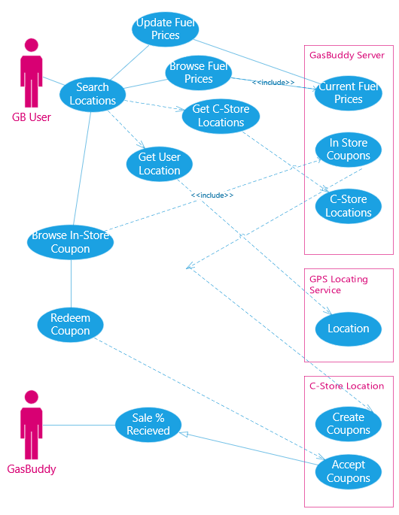

## **Figure 3. Final Implemented Design (Search Page)**

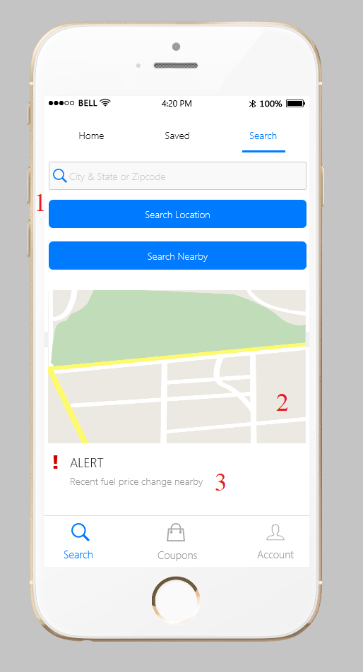

## **Figure 4. Final Implemented Design (Coupon Page)**

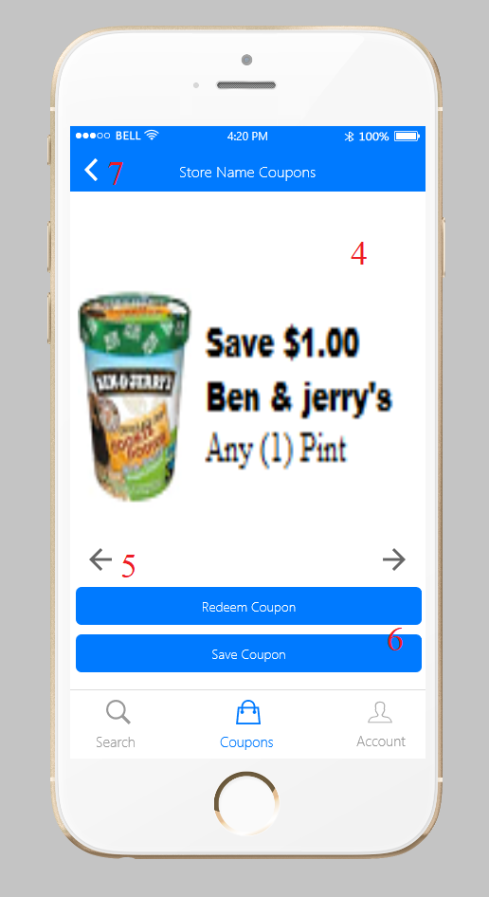

## **Design Explanations**

1. Ability to search for fuel stations by entering in a city/state, a zip code, or by using the search nearby button to search the area nearby the user. Searching nearby will require the user to allow permission to access their location.
2. GPS map showing the nearby locations or the locations in the area searched by the user. Map should show pins for the locations and provide information when clicked.
3. GasBuddy alert area. This area should show different alerts such as recent fuel changes, saved coupons expiring soon, and other relevant alerts.
4. In-store coupons. This area will show the various coupons available at the selected store. Area should be large enough to easily view coupons.
5. Coupon navigation buttons. Simple buttons to allow the user to navigate through all the coupons offered by a location.
6. Redeem & save buttons. These buttons should allow the user to either redeem a coupon (this will populate a barcode for the cashier at the location to scan) or save a coupon. Saving a coupon moves it to the users saved page, allowing them to easily come back to the coupon at a later time.
7. Return navigation. This should be included on each page that moves away from the main page or navigation of the mobile application to allow for the user to easily return the previous screen without needing to restart the application.